Day 6 – ***DEPLOYMENT PREPARATION AND STAGING ENVIRONMENT SETUP AS-FOOD:***

Deployment Link: https://foodtuck-red.vercel.app/

*Add Environment Variables to deployment :*

When deploying your application, ensure that the hosting environment is configured with the same variables as in your .env variables as in your .env file .

Deployed on -> Vercel

Environmental Variables set:

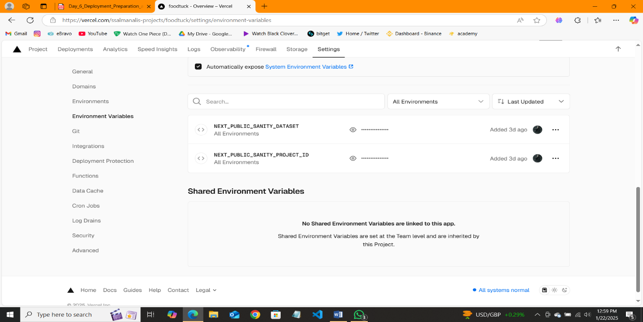

*Checking Performance:*

* Performance = Excellent Performance
* Accessibility = Easily Accessible and loads quickly
* Best Practices = Very good Adherence to coding and security
* SEO = After additional SEO this could be even better.

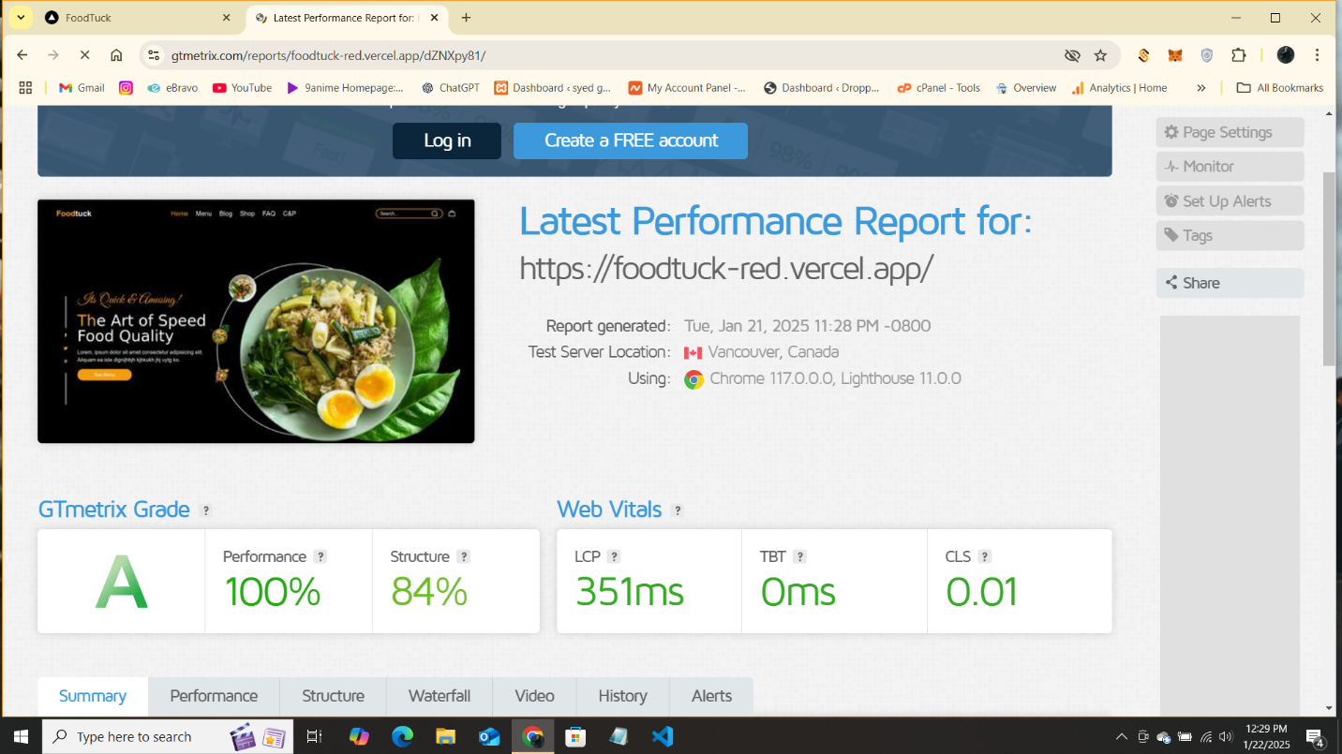

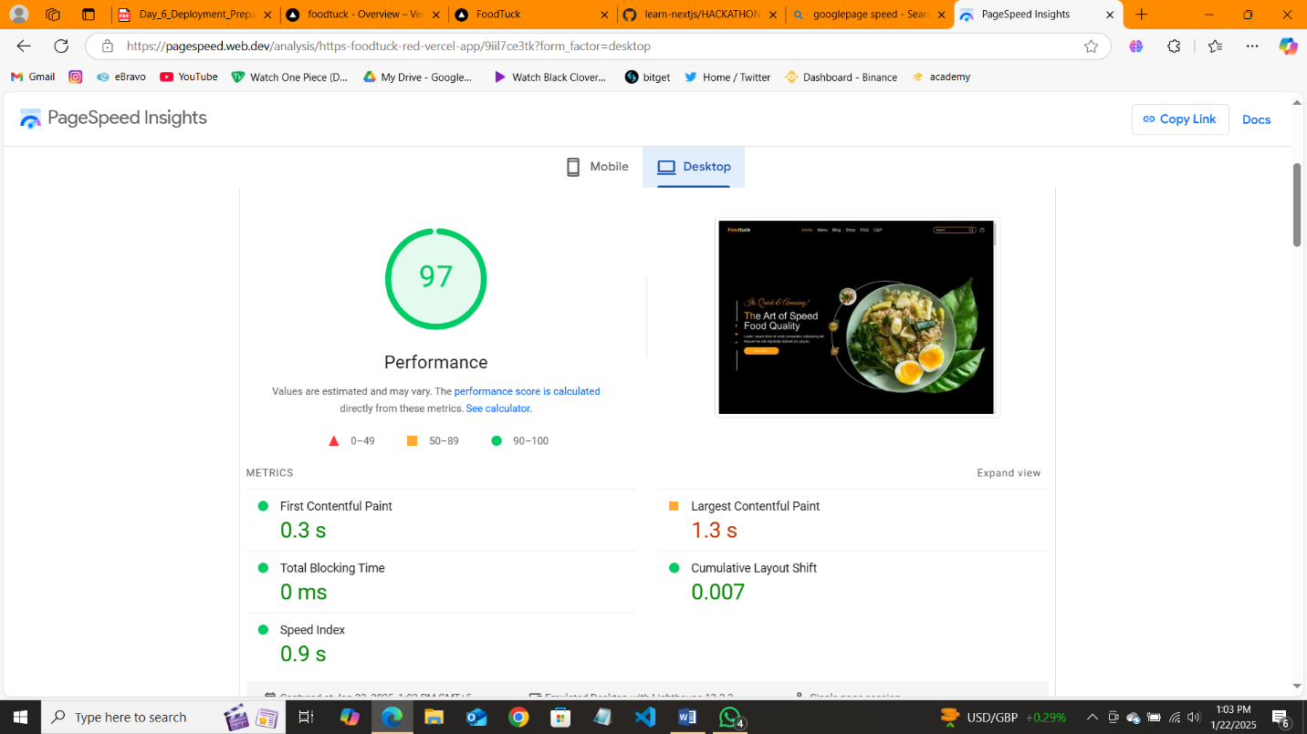

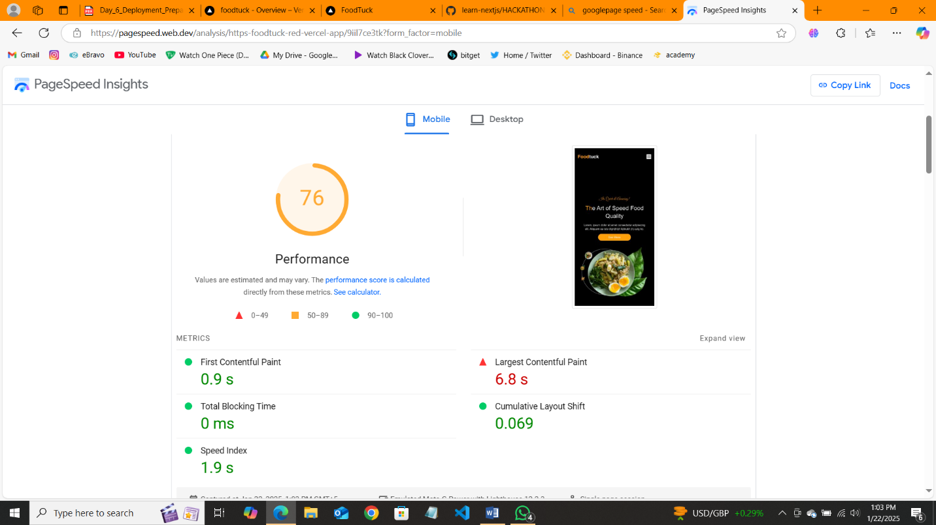

Staging Deployment = These logs represent the static page generation build traces collection, and page optimization steps during a web application build process. The primary focus of the logs is to detail the route-specific build data including

1. Route name

2. Size

3. First load JS

